March 2, 2018 notes – by nic

Cascading Style Sheet (CSS)

- Started in 1994

- By Hakon Lie and Bert Bos

- Can be used for all structural markups.

- Mainly used for the aesthetics of a page.

- Added in HTML v 4.0

CSS Syntax

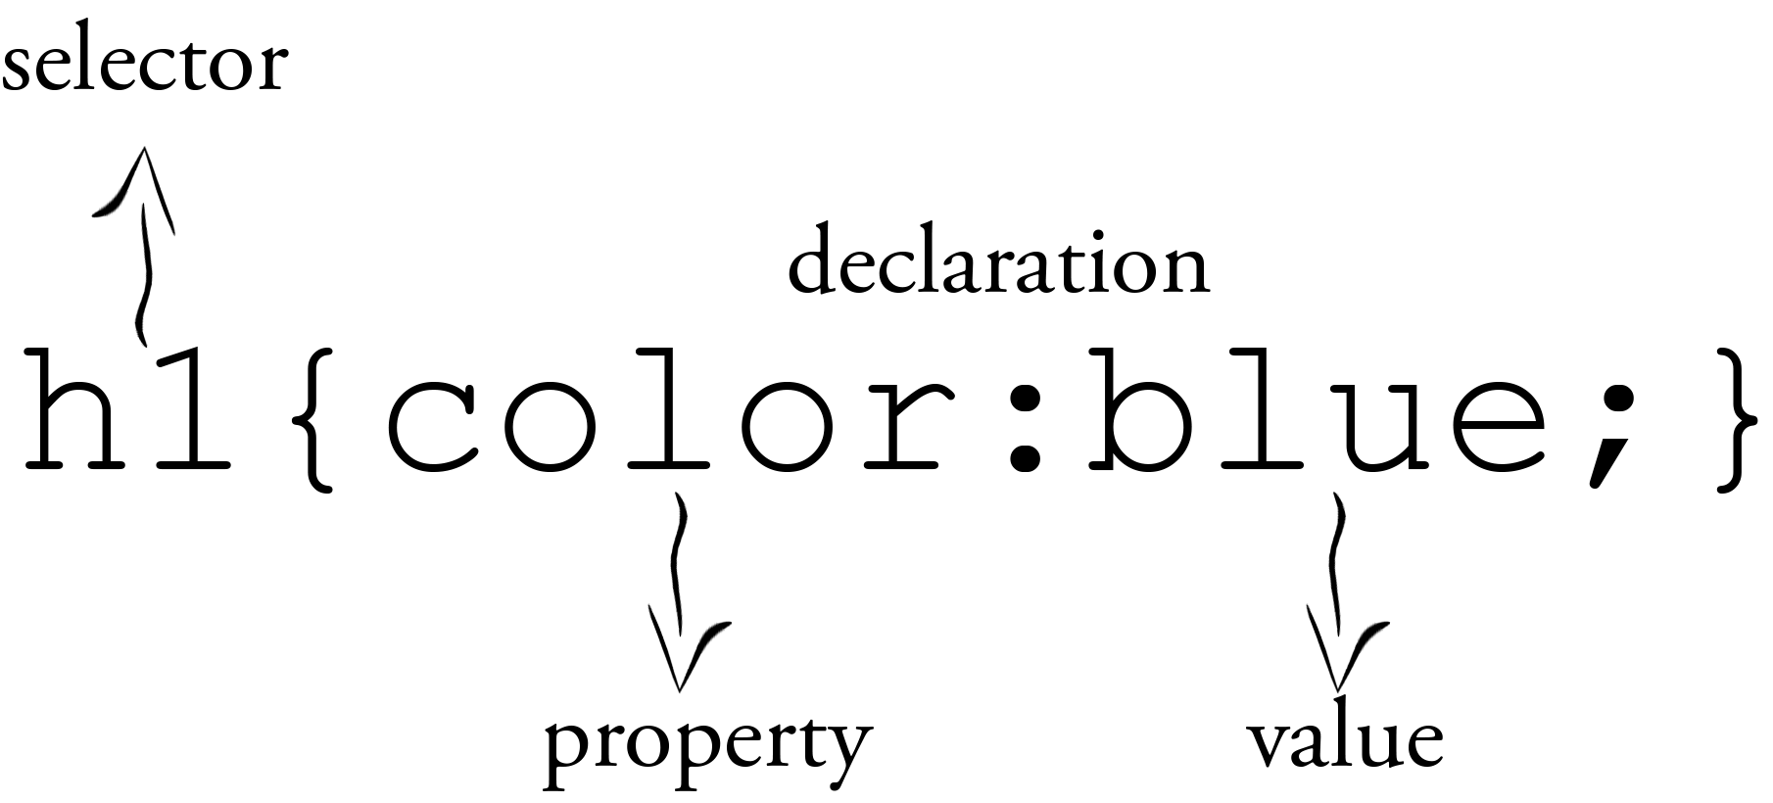

Types of CSS

1. Internal

<html>

<style>

body {

background-color: green;

}

</style>

</html>

2. External (recommended because its reusable and for consistency purposes)

<link rel="stylesheet" href="style.css">

3. Inline

Ex: <h1 style= “color:blue; text-align:center”> webtech </h1>

CSS Levels

|  |  |
| --- | --- |
| Level | Year |
| 1 | 1996 |
| 2 | 1998 |
| 2 Rev. 1 | 2011 |
| 3 | Modular Approach to CSS development |

References:

https://www.w3schools.com/css/css_syntax.asp

https://www.w3.org/standards/webdesign/htmlcss